Working with Loops

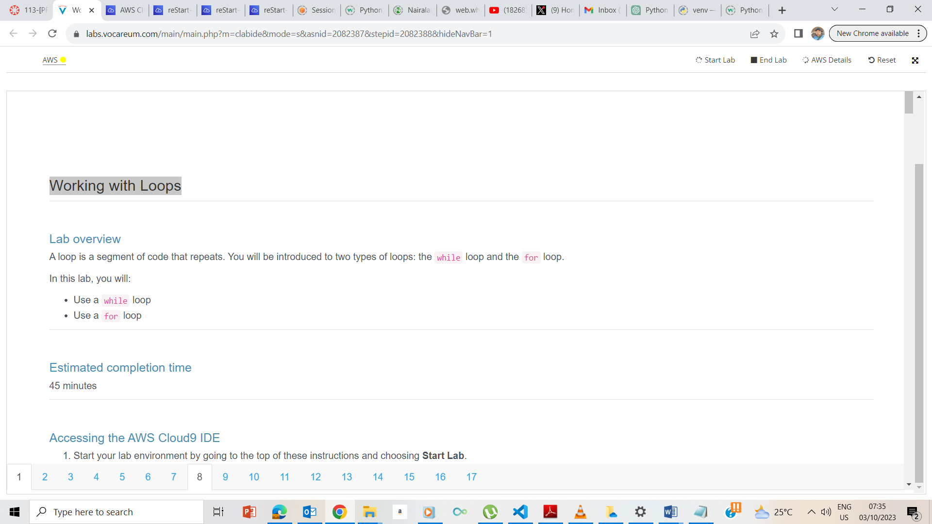

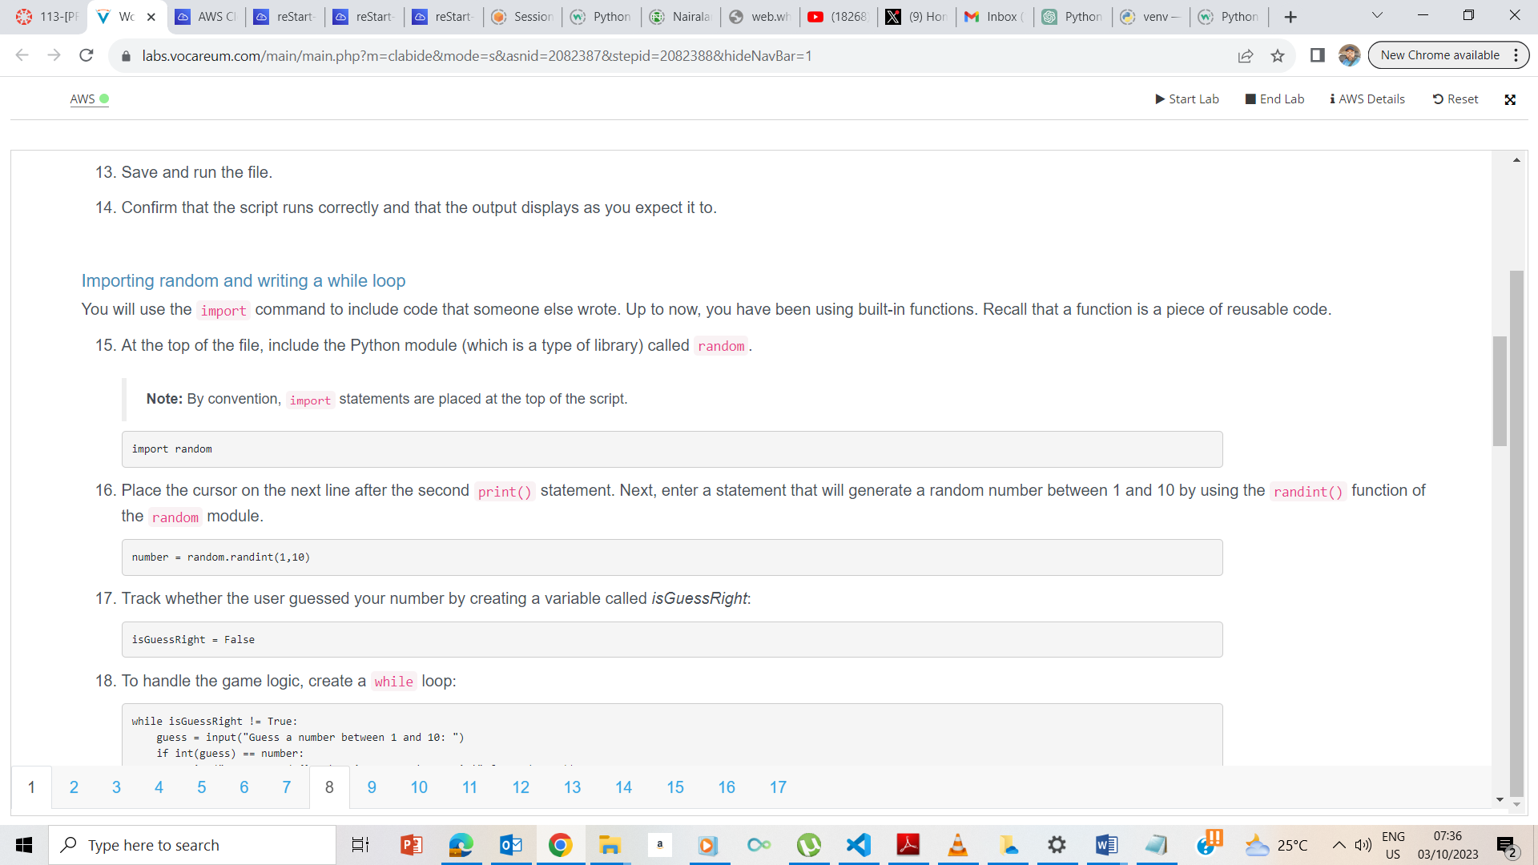

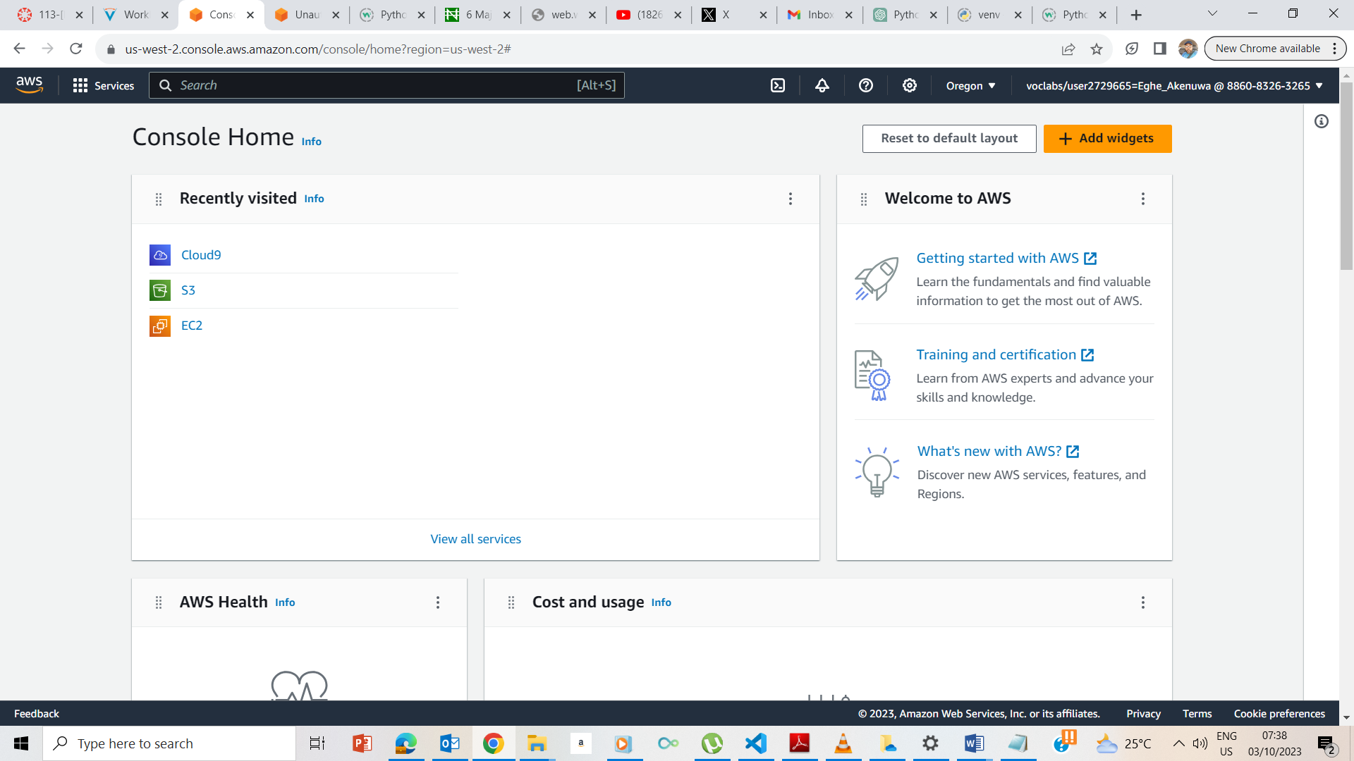

I clicked on the Cloud 9 console on the AWS management page as done in previous labs

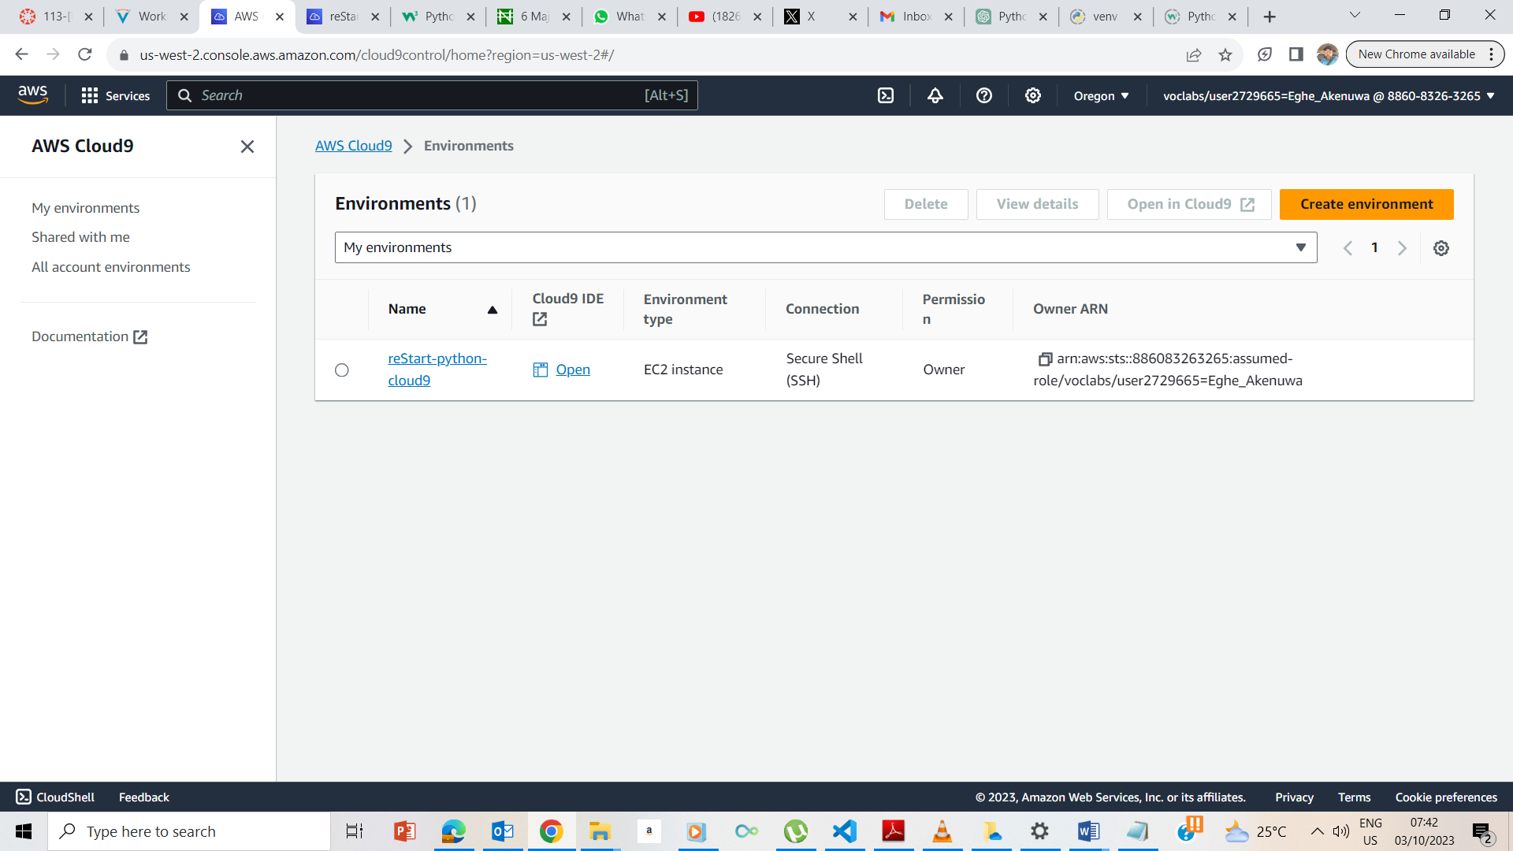

I clicked on the openIDE icon on the cloud9 page

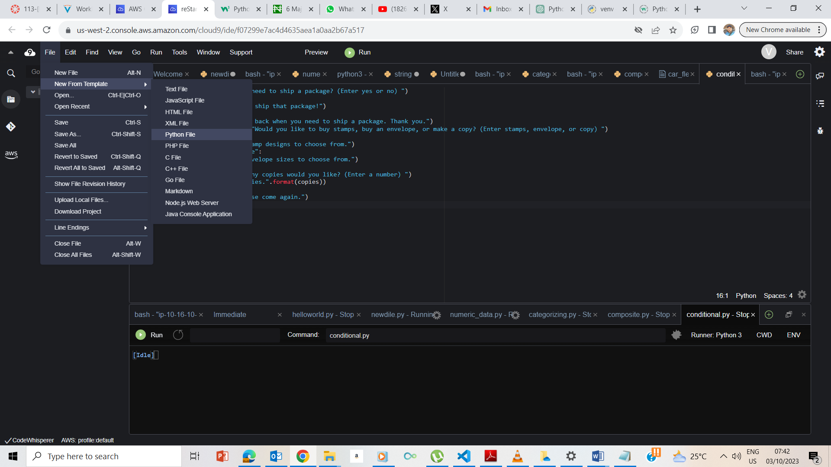

I clicked on the file -> new from template -> python

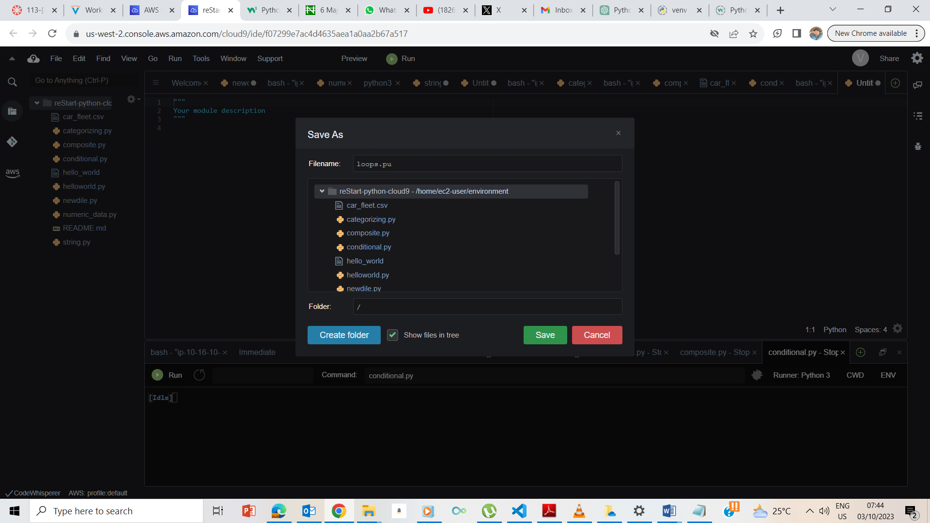

I saved the file.

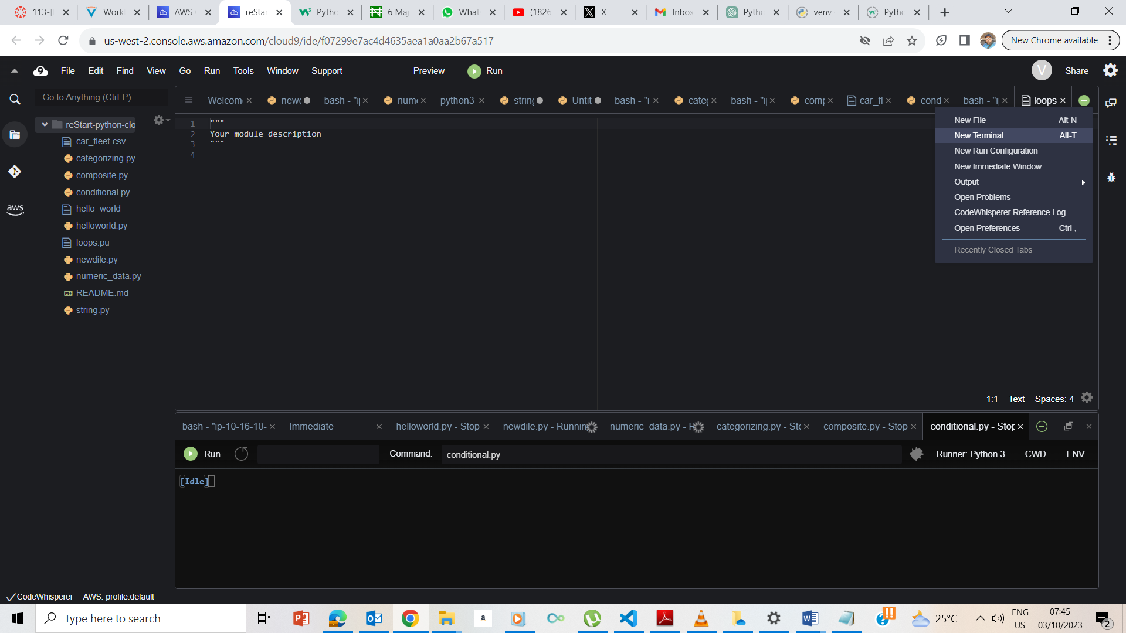

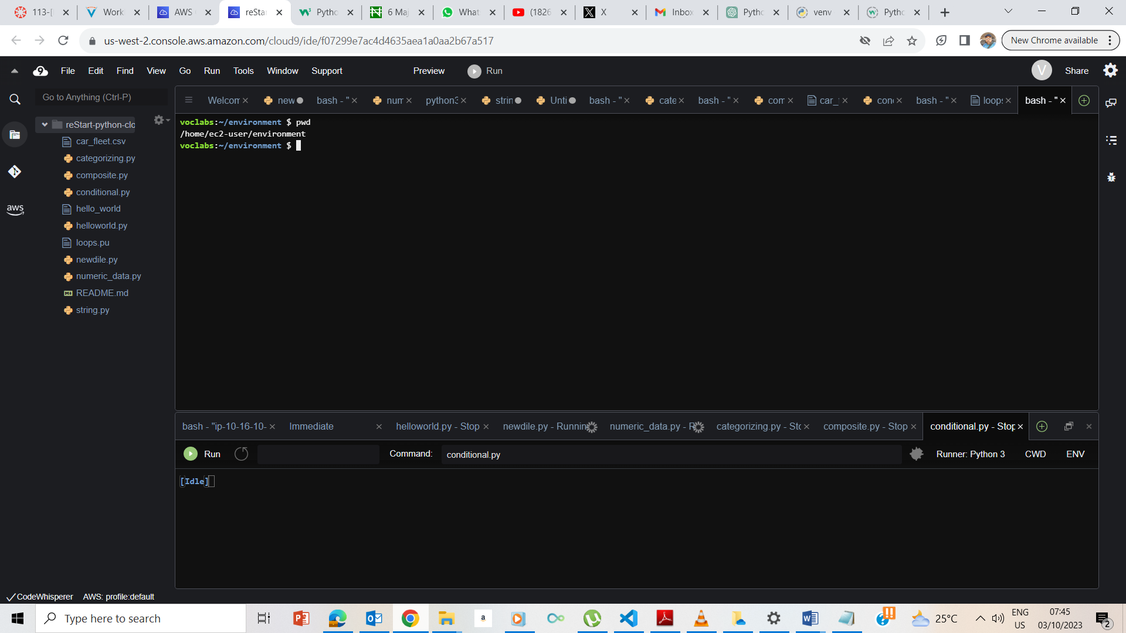

Clicked on new terminal, and on the new terminal, typed pwd to confirm that I am on the ec2-user/environment.

## **Exercise 1: Working with a while loop**

### **Printing the game rules**

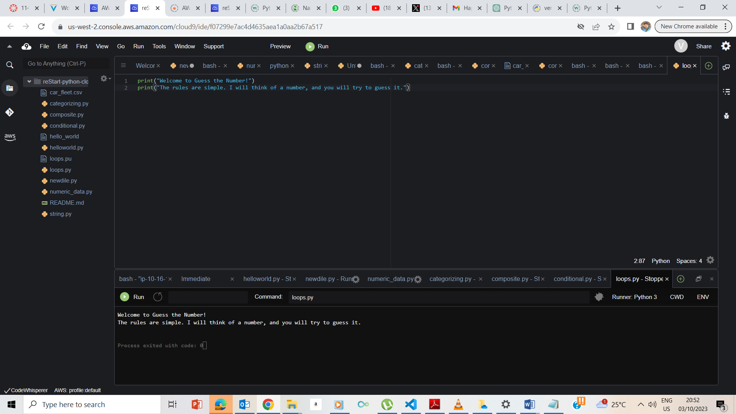

The rules are printed as instructed.

### **Importing random and writing a while loop**

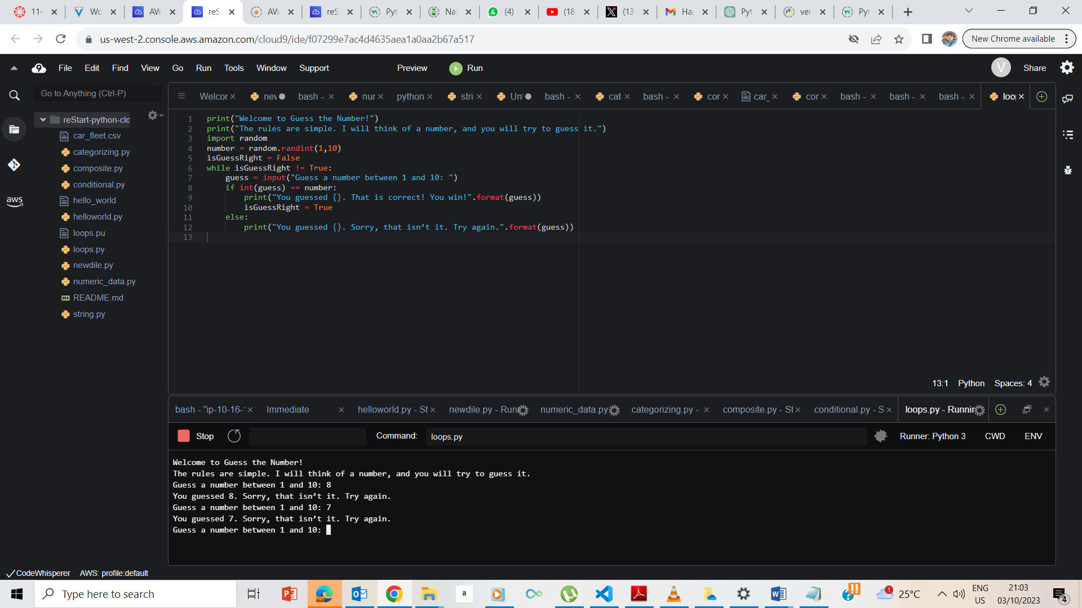

The code runs as expected.

### **Informing the user about the script**

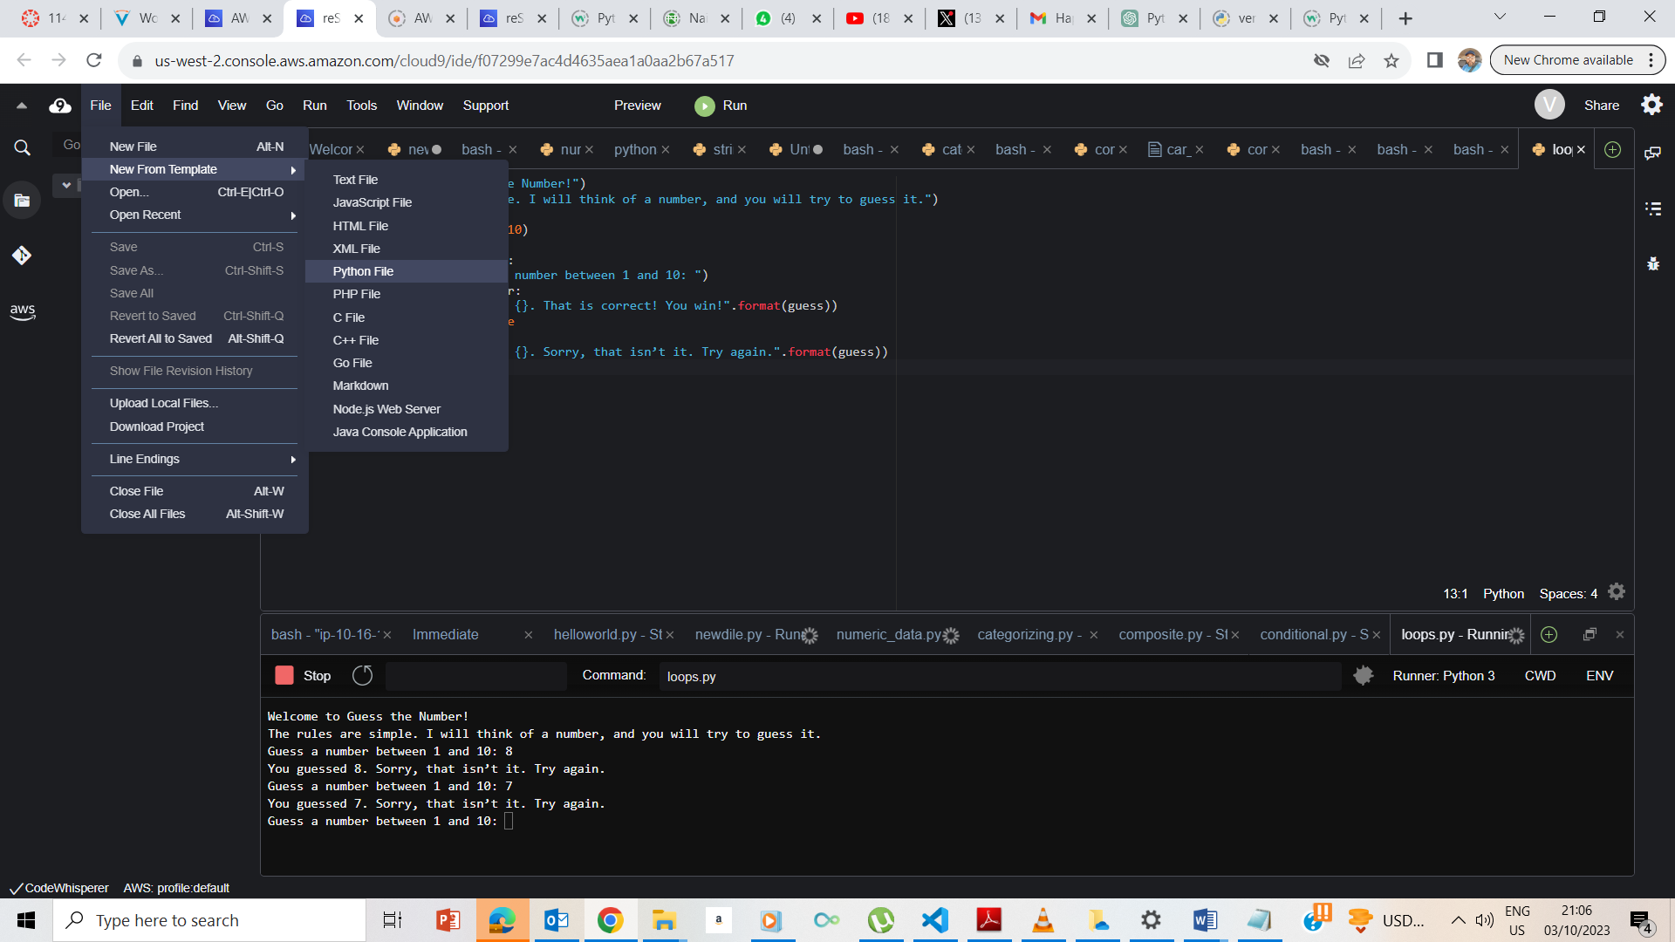

Creating a new Python file from template.

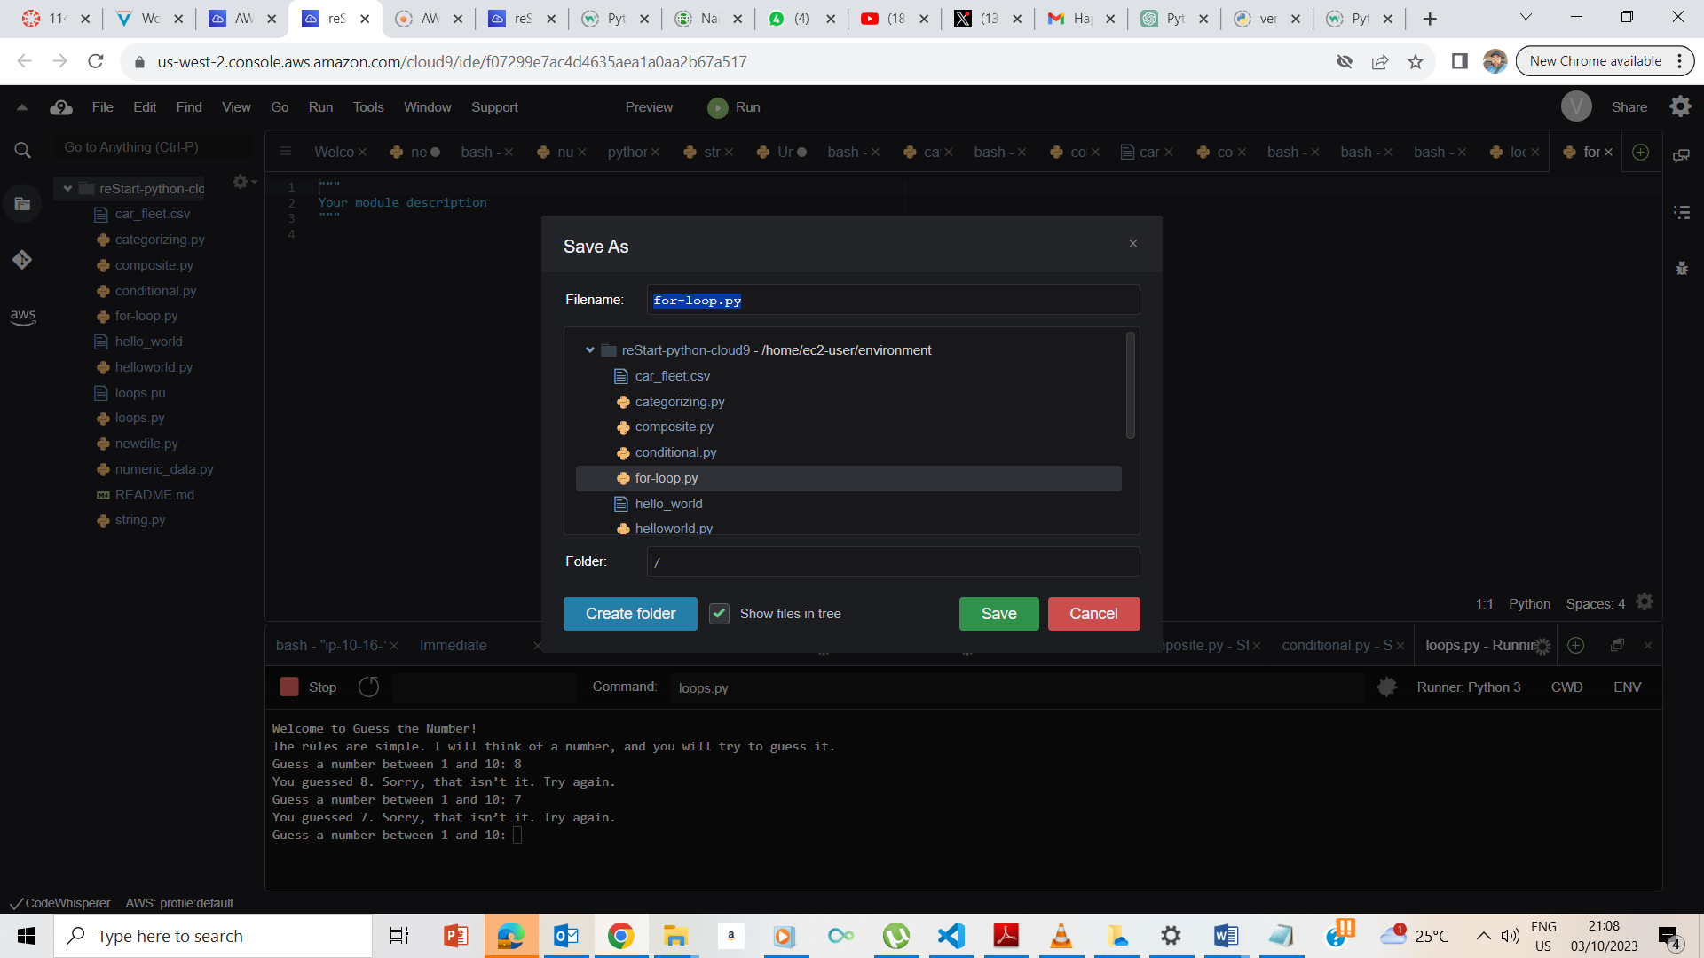

Saved the new file as for-loop.py

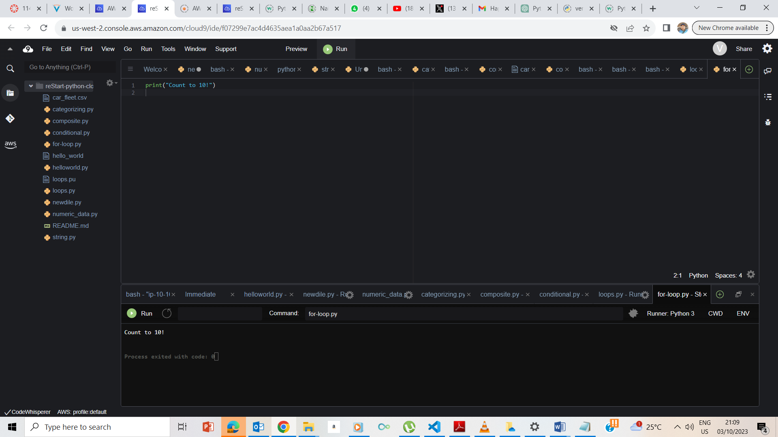

I typed the code print ‘count to 10’ and ran it, and it ran as expected.

### **Writing the for loop**

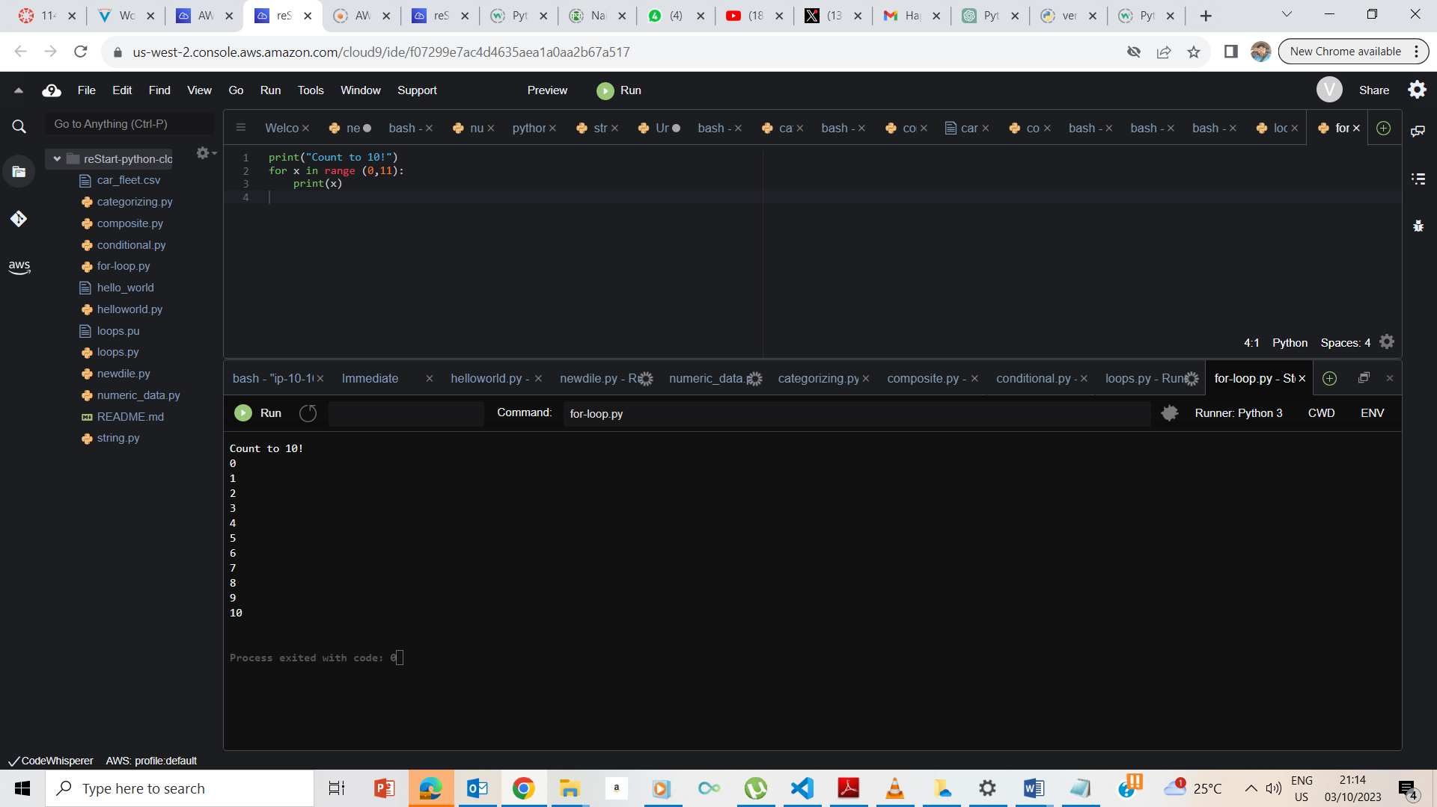

The code:

for x in range (0,11)

print(x)

prints out the numbers 1 to 10

## **End Lab**

